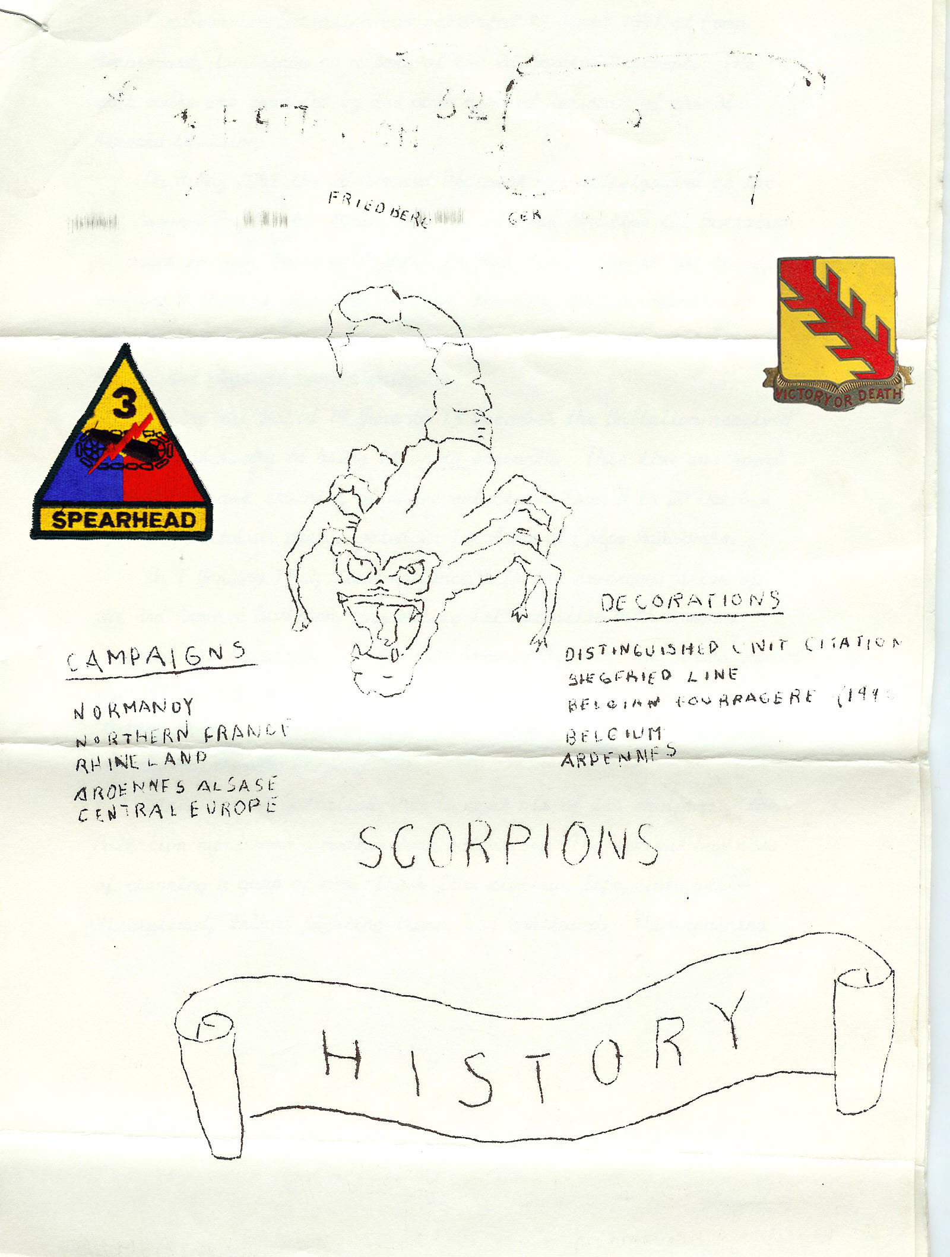
Introduction to the “Scorpion History”

This has been my attempt to transcribe the 3rd Battalion 32nd Armored Regiment history. In 1965 Lt.Col. Samuel T. Rhodes (the battalion commander at that time) had this document issued to every battalion member. It has now bee 42 years since, and the paper which was of poor quality then, is getting so bad and the ink fading away I thought I needed to reproduce this now. I have done the best I could from the old text but there are a few words left out because they couldn’t be interpreted. Most of the text is exactly as it was given to us. I haven’t changed the grammar or punctuation. The reason this ends in 1965 is simply because that is when he had the document produced. I think one of the battalion clerks typed it up and then made copies for all Battalion members. I just wanted to get this into digital format before the paper becomes unreadable. It is nearly that way now. It was originally produced on legal size typing paper and was in “script type”.

Hopefully someone will read this and be able to add to it beginning in 1966. The Scorpion Battalion participated in FTX “Silver Talon” in January 1966. There are some photos on this website showing an M-60A1 tank causing a derailment near the small town of Burgenheim, Germany. This was on January 11, 1966. The two tanks involved were from the 1st Battalion, 32nd Armor. During the critique of the FTX at the Ray Barracks Kasene the Commanding General of the 3rd Armored Division advised us that we were successful in causing the most damage to the Bundes-Bahn (German Railroad) since the end of WWII.

Shortly after this FTX I rotated back to the USA.

C. Jacob Greeling

Former member of the 3rd Battalion 32nd Armor, 3rd Armored Division.

The Scorpions History

The Scorpion Battalion was activated 15 April 1941 at Camp Beauregard, Louisiana as a part of the 2nd Armored Regiment. The unit cadre was provided by the 66th Armored Regiment of the 2nd Armored Division

On 8 May 1941 the 2nd Armored Regiment was re-designated as the 32nd Armored Regiment. During the period from the time the Battalion reported to Camp Beauregard until 10 June 1941, when it was transferred to Camp Polk, its permanent station, the training was devoted to improving the skills of the cadre personnel in driving, Maintenance, drill and physical conditioning.

During the period 19 June to 13 December the Battalion received recruits necessary to bring it up to strength. This time was spent continuing basic training of the selectees. From 8 to 20 October 1941 the Battalion participated in 1st Armored Corps Maneuvers.

On 1 January 1942, in compliance with the re-organization of the 3rd Armored Division, the entire 1st Battalion 40th Armored Regiment was transferred to the 32nd Armored Regiment and re-designated the 3rd Battalion 32nd Armor, whose personnel were used to fill in mainly, Headquarters Company, Service Company, Reconnaissance Company and the Maintenance Company.

Since the 1st Battalion 40th brought all its equipment, the Battalion now became a medium tank battalion. The serious business of changing a group of men, fresh from civilian life, into well-disciplined, trained fighting teams, was continued. This training program, which included everything from overnight bivouacs to greasing bogie wheels, and began to leave its telling mark on the battalion.

The 3rd Battalion, under the command of Major John Scoville, was the first unit of the Division to be called upon to use General Gulem’s “Golf Course” problems, a series of “canned” exercises written for tank platoons. The battalion was again first to use the Pitkin Range, where the power and accuracy of the 75 mm tank gun was first demonstrated. There was range
firing for weapons of every description during this period, and it was on these ranges that the old adage of “Hold’em and squeeze’em came into its own.

Training continued at Camp Polk until the first week of July 1942. At this time the unit moved to Camp Young, California, located in the heart of the Mojave Desert. The Battalion set up camp on the Eastern slope of the Granite Mountains and immediately commenced the adjustments necessary for life in the desert.

From the standpoint of training, the desert was magnificent. There were no land or area restrictions. Since there were absolutely no distractions, the training program was absorbed to the fullest. The CO was able, for the first time, to see the full battalion formation. Tank crews were transformed from six individuals in an armored vehicle, into a compact group of trained specialists. The tanks, which were in current use at that time, were the M-3’s. About the middle of September, the first M-4’s were brought out and assigned to the companies. A long, 2000-yard range was built, and all members began to get the feel of their new vehicles.

During the Desert Training Period the Battalion was inspected by many important persons, including Major General Gillem, then commanding the Mojave Desert Training Center, Major General Walker, the commanding IV Armored Corps, and Division Commander Major General LeRoy H. Watson.

On 21 October 1942 the Battalion moved again. This time the destination was Camp Pickett, Virginia. The adaptation to damp, chilly climate was soon made and training continued.

On 27 December, the Battalion, then under the command of Lt. Col. Walter B. Richardson, was selected as “guinea pig” for experimental training of an amphibious nature. One week was spent aboard an LST, during which time the personnel and vehicles disembarked and embarked under the most adverse weather conditions imaginable. The ship, under British Command, was expertly manned. Both the British and Americans alike respected the efforts of the other, and a very genial condition existed throughout the entire experiment.

The next transition took place on 10 January 1943. The Battalion moved to Indiantown Gap Military Reservation, Pennsylvania. There was no diminution of training at the new camp; in fact, an accelerated program was put into effect. Road marches and command post exercises went on as usual, tankers learned the fine points of indirect fire, and the pine-clad slopes of the Blue and Center Mountains echoed to the rumble of 75-mm tank fire. In complete disregard of deep snow and bitter cold, gunnery, maintenance and physical conditioning were the touchstones of progress. It was here that the Battalion personnel gained the winter weather know-how that was to stand them in such good stead during the hard Ardennes struggle two years later.

As spring and then summer come to the Pennsylvania hills, the Battalion engaged in platoon, company and battalion tests and small arms qualifications.

On 15 April 1943 the Battalion participated in a Division Review honoring the Second Anniversary of the 3rd Armored Division. Governor Edward Martin, of Pennsylvania, who was also a Major General in command of the Pennsylvania National Guard, was the Guest of Honor.

The Battalion was alerted for overseas movement early in August 1943. The advance detachment left the Gap on 9 August 1943, arriving in Liverpool, England on 21 August.

On 26 August 1943 the Battalion was moved to Camp Kilmer, New Jersey. Passes were cancelled on 2 September and the Battalion boarded the “Capetown Castle” on 4 September 1943.

As on all troop transports, conditions were extremely crowded. This was the first voyage for most of the officers and men. There were only two meals served daily aboard ship, but even this necessitated long chow lines, and did not ease the discomfort involved by all concerned. The Battalion again showed the stuff of which it was made, by taking every un-pleasantry in its stride, and not once complaining.

It was a bedraggled looking outfit that dropped anchor in Liverpool, England on 15 September 1943. Those miserable’s who had suffered from the effects of “Mal de Mer”, had reached the point long ago where it made no difference whether the “Capetown Castle” made a safe crossing or not. When land was sighted the spirit of everyone was raised. Maybe things weren’t going to be too bad after all.

The Battalion loaded on trains and arrived at Codford Camp, England on 17 September 1943. The personnel soon settled into their “nisson Huts” and began receiving their new equipment. Soon the Battalion was able to resume its training. Towards the end of December, the first of a long series of CPX’s was held.

During its stay in England, the Battalion was inspected by a number of high ranking officers. General Bernard Montgomery, Commander of the British Eighth Army visited the Battalion and Regiment on 17 January 1944, and was followed in the ensuing weeks by General Dwight D. Eisenhower, General Omar N. Bradley, Air Chief Marshall Tedder, and the Duke of Gloucester, brother of King George VI.

On 23 April 1944, it was decided to move the Battalion’s present billets into the field. The move was completed without incident, and the new camp area was established some 400 yards north of the Codford “B” Camp, on 1 May 1944. By late May the invasion appeared imminent and all were awaiting word to proceed immediately to ports o embarkation. All vehicles were water-proofed, combat loaded and ready. Maps of the Continent had been issued to officers and non-cons. Conversation was all of D-Day and H-Hour.

The battalion expected to go into combat on the morning of the invasion, but when the first wave of Allied might struck the Normandy beaches on 6 June, the Battalion still rested on the downlands near Codford. Ten days later the unit left its bivouac and proceeded to the port of embarkation. However it was not until 23 June that the Battalion went ashore on Omaha White Beach, east of Isigny on the Cherbourg Peninsula. Assigned to an area a short distance from the beach, the troops spent their first days in France de-waterproofing and preparing for combat operations.

The Battalion, as part of the 3rd Armored Division, one of the United States’ largest tank outfits, had been designed and trained for all-out attack. Its mission in Europe was two-fold: To pierce enemy front line defenses, and to run amuck, cutting German supply and communications lines, preventing the organization of enemy reserve forces, and destroying the enemy’s very will to fight. The Battalion, with the Division, now devoted all its resources to accomplishing that end.

The Battalion received its introduction to combat on 29 June 1944, near the town of Villiers Fossard, northeast of St. Lo. It was here that the men first heard the chilling shriek of “incoming mail”. They learned quickly that there is little glory in combat, and that victory often comes at an exorbitant price.

They discovered that the Germans were good soldiers who could fight and fight hard; that frontal attacks on hedgerow positions were suicide; that tankers could not stop for a break wile under enemy observation. Lt. Col. Richardson was awarded the Bronze Star Medal for meritorious service in action on 29 June.

During the early part of July, the battalion was attached to the 9th Infantry Division and was engaged in the area of St. Jean de doyen where it fought bitter small engagements against parachutists and SS panzer elements.
Routing strong entrenched enemy forces, it occupied the terrain overlooking (Le vt) (not readable) and was employed as separate tank companies in support of infantry battalions.
On 16 July the Battalion reverted to 3rd Armored Division control and moved to an assemble area where it prepared to become part of that crack assault force which was to lead the U.S Forces to the German Heartland.

After ten days of massive bombing by Air Corps, the Battalion attacked as part of Combat Command “A”, through gap made by the 4th and 9th Infantry Divisions. The mission was to pass Mariny and turning southeast to take Cerisy La Salle, Montpinchon, and the high ground around Coutances near the west coast of Normandy. Heavy opposition was encountered; the enemy apparently had expected such a sweep. But the tankers blasted their way through enemy positions and stalked German units through towns, over hills and river beds, taking many prisoners and capturing or destroying a large numbers of enemy vehicles and supplies. In the white heat of battle, the 3rd Battalion had begun to mold into a great fighting unit. Though it was green, still learning it was charged with a burring drive which, in the days ahead was to be its hallmark. Welled well trained and alert, the men needed only those flaming days in Normandy to provide experience.

The ensuing two week operation from the breakthrough near St. Lo the reaching of the Magenna river near 60 miles to the south was one of continual all out attack, by 12 August, the German forces in northwestern France had been thoroughly beaten and were withdrawing eastward in an attempt to escape encirclement.

The 3rd Battalion was ordered to drive northward to help close the escape gap of Field Marshall von Kluge’s Seventh Army. The battalion drive northward sometimes cut-off, sometimes surrounded but always moving forward. The tankers moved on against stubborn resistance, and on 18 august linked up with units of the 12th British Army Group near Fromentel. The Argentan-Falaise gap was closed.

After completing mopping-up around Fromentel and resting for several days, the 3rd Battalion moved on 22 August for the Seine River, just south of Paris. On 26 August the Battalion crossed the Seine in its customary leading position and moved northward. By the end of the month it was nearing the Belgian border.

On 2 September the Battalion crossed the Belgian border south to Mons, completely routing and disorganizing the enemy. The enemy was again cut off and lost many casualties. The Battalion now swung east and raced toward Aachen. Inspired by the victory at Mons, the unit covered 90 miles in one week’s time. The Battalion reached the Siegfried Line on 13 September and immediately commenced to breach it. In two days of savage fighting the mighty defenses were overcome. Now after racing from the Seine River to the Siegfried Line in eighteen days and smashing through those legendary defenses, the Scorpion Battalion had to pause to secure its flanks. The supply lines had to be shortened, the men rested, and maintenance performed.

On 26 September the Battalion was sent into 3rd Armored Division reserve and remained as such until 7 November when it reverted to Combat Command “A” control. Activity was limited mainly to providing road blocks and rear area security. There was little change during the first half of November while the whole division regained its strength for the next leap forward.

On 16 November the Division jumped off to secure bridges over the Rhine in the vicinity of Cologne. Combat Command “B” was soon halted and CCA, with Task Force Richardson (3rd Battalion) in its usual leading position, took up the slack. Through impassable mud, extensive mine fields and heavy anti-tank fire Task Force Richardson maintained it’s steady but costly advance seizing (unreadable). After turning this position over to the infantry the battalion reorganized and refitted. (Can’t read the next sentence).

On 16 December 1944, Field Marshall Gerd von Rundstedt commenced the massive counter-attack we call the Bulge. On 18 December our Battalion was attached to V Corps and moved south to blocking positions near Eupen. Through the critical days of late December our Battalion maintained a policy of attacking southeast against the penetration. This offensive defense gained time to allow the formation of the forces necessary to reduce the Bulge. On the morning of 30 December the entire Division was pulled out of the line in order to rest and refit.

From 3 January on the Battalion slugged its way across Belgium against a vicious defense. But by early February our unit had regained the position where it had been deployed before moving into the Ardennes. On 5 February the tankers went into 3rd Armored Division Reserve and remained there until 25 April 1945.

When the Division bogged down near Elsdorf, Task Force Richardson now in division reserve was again committed. The Battalion moved forward to make a bridgehead over the Erft-Kreis near Elsdorf on 28 February, and the first Speardhead Tanks rolling on the plain before Cologne were from the 3rd Battalion.

On 3 March the assault began on Cologne and within 4 days this major objective was reduced. After being relieved by elements of the 104th Infantry Division, the tankers waited for the next attack.

Our Battalion was attached to the 1st Infantry Division on 20 March and smashed north and east from Honnef, south of Bonn. The rest of the Division followed and soon the Battalion again reverted to Division control.

The Battalion moved swiftly east to Marburg and then north towards Padderborn, covering over 90 miles in one day. As they neared Padderborn resistance stiffened as they encountered elements of the SS Panzer Replacement and Training Center located there. Against the heaviest enemy bazooka fire ever encountered the battalion sized Kirchborchen , 6 miles below Padderborn. On 30 March the Division Commander Major General Maurice Rose was killed just south of Padderborn.

Early on 2 April Padderborn was sized and the Battalion moved east. The tankers raced toward the Elbe. The unit reached Dessau on 21 April securing it the next day. Then on 25 April the Division was completely relieved by the 9th Armored Division.

After brief occupation duty the Division and component parts were de-activated in a formal ceremony in the Kaserne at Aalen, Germany on 10 November 1945.

The Scorpion Battalion was disbanded 7 July 1947. It was reconstituted and re-designated 28 May 1948 as Company “C” 61st Heavy Tank Battalion. It was activated 12 July 1948, at Fort Dix, New Jersey and re-designated 25 May 1954 as Company “C” 21st Tank Battalion. Inactivated 1 December 1957 at Fort Carson, Colorado, it was concurrently re-designated as Headquarters and Headquarters Company, 3rd Medium Tank Battalion (Patton), 32nd Armor and was activated at Fort Stewart, Georgia. During their stay at Fort Stewart the members of the 3rd battalion again exhibited their excellence. Commanded by Lt. Col. Harry McNamara, JR. until July 1960 the unit was quickly made operational in all respects as was evidenced by being designated as a member of the United States Strategic Army Corps, and receiving the STRAC Superior Unit Award for the training year 1959.

Lt. Col. Clifford E. Mize assumed command of the Battalion on 27 July 1960 and continued the fine record. Again the unit received a STRAC Superior Unit Award for the training year 1960.

Reorganized and re-designated 1 September 1963 as 3rd Battalion 32nd Armor, the unit was once more assigned to the 3rd Armored Division.

Lt. Col. James A. Manning assumed command of the Battalion as it was reassigned to the Division concurrent with its reorganization under the ROAD concept. The Battalion, now nicknamed “The Scorpions” was provided with the cast off equipment of four other battalions. But hard work and long hours overcame this obstacle and the “Scorpion” Battalion took its rightful position with the older units in the Division. “The scorpions” exhibited their prowess in numerous field exercises, such as “Big Lift”, when the division out-classed the 2nd Armored Division, and “Winter Track”, when the 3rd Brigade aggressed against the 8th Infantry Division. During all exercises and training the battalion received nothing but praise from all who observed it in action.

On 1 July 1964 the Mantle of Leadership of “The Scorpions” passed to Lt. Col. Samuel T. Rhodes. Under his guiding hand the Battalion has been shaped and molded into an even finer instrument.

The Battalion at last began to receive new equipment. The new command post vehicle the M577, replaced the M113’s being used for this purpose. M60A1 tanks are being received to replace the M60’s as they become old and worn. M106 Mortar Carriers have replaced the obsolete M84’s with which the Battalion had originally been equipped.

The Scorpions trained at Grafenwohr from 13 August to 3 September. During this time all platoons successfully completed tests and the tankers were able to do some familiarization firing with all tank weapons. Major General Berton E. Spivy, 3rd Armored Division Commanding General, visited the unit and went downrange on one of the “Scorpion’ tanks.

The Battalion participated in CPX “Fallex 64” and several field exercises during which the companies successfully completed tests. On 5 December 1964, the Scorpions moved out on FTX “Gallant Sword”, a week long exercise during which the 3rd Armored Division was opposed by German Army units. The “Scorpions” successfully completed the battalion tests concurrent with this exercise and won high praise from all umpires.
Tank gunnery has been the focal point of all training during 1964. All of the Scorpions have been working long and hard to insure that everything possible has been accomplished. Everyone is confident that the Scorpion Battalion will again lead the Spearhead Division in qualification on Range 42 at Grafenwohr.

After the FY 65 ATT’s, every effort turned towards the tank gunnery qualification program. During the Division Course held at Grafenwohr in January and February 1965, a Scorpion tank crew won the Commanding General’s Trophy for achieving the highest score in the Division (1870 points). The crew members were SFC Grier, SP4 Truxal, PFC Daves, and SP4 Rittmeller.

Also in the spring of FY 65, the Scorpion Battalion Armored Cavalry Rifle Squad won fourth (4) place in the Division Mechanized Infantry Proficiency Course, which was conducted at Hoenfels. The squad competed against one hundred and twenty-five (125) other squads from Division units. It members were: Squad Leader Clarence J. Greeling (SGT), Alpha Team Leader Henry Norris (SGT), Bravo Team Leader Richard Owen (SGT), and the six (6) rifleman were- SP4 Gilbert McCann, SP4 Charles Simon, SP4 Paul Thompson, PFC Stanley Carriveau, PFC Louis Johnson, and PFC Lee Smith.

March 1965 saw the Armored Cavalry Platoon Scout Section participating in the Division Scout Crew Qualification Course at Wildflecken, Germany. SSG William W. Adams’s M114crew won 1st place, and the entire section, under the outstanding Leadership of 1st Lt. Thomas M. Montgomery placed second in the Division competition. Members of the section were: SSG Luis Bumalag, SGT Loy Lee, SGT Randall Mosely, Sp5 James Parker, PFC Leroy West, PFC Harold Sooter, PFC William Ousley, PFC Terry Wright, PFC John Curtis, PFC Zenon Pomaski, PFC Charles Kassay, PFC Louis Johnson, and PFC Russell Verbeke.

In May of 1965 the Scorpions achieved the highest scores ever recorded on the Division CMI. Upon completion of this inspection the Battalion began earnest training for Platoon ATT’s to be held in Hoenfels in July 1965.

On 17 June 1965 the Battalion conducted a mounted review to honor the wining company in the Scorpion Panzer Trophy competition. The ADC/M General Wheeler G. Merriam and the 3rd Brigade Commander, Colonel James W. Cavender was present.

